3 hours
Most of the program went well while coding.
Executing an else statement before an if statement was an issue I had. (In the end it was the logic I set for the program, oops). I also had an if statement get ignored.
Had a lot of fun coding thing and showing my brother! Part of the output when I let him run it howerver was:
You have the following ingrediants on you Pizza:
['A Car', 'Cheddar Cheez', 'Cheez-Its', 'Battery', 'Toxic Wast', 'Wall Plaster', 'My Discord Account', 'A Birthday Cake', 'My Lunch', 'A Pen', 'My Bill', 'Potato Sacuce', 'Mashed Green Beans', 'Straw', 'Blue Radioactice Gel', 'My House', 'A 38.9% Of A Pizza Crust', 'Cow', 'My Neighbors Dog', 'Some Shattered Sugar Glass', 'Some Dihydrogen Monoxide', 'Magnisiom Florid']

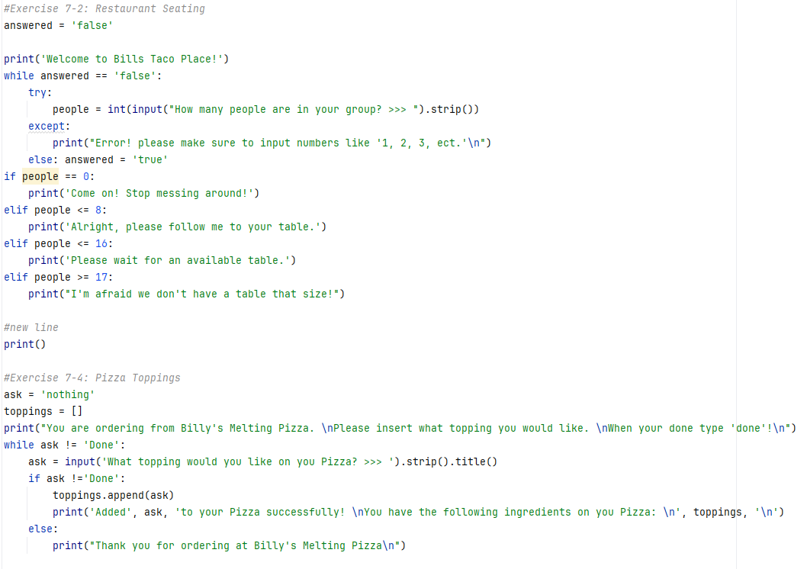
Program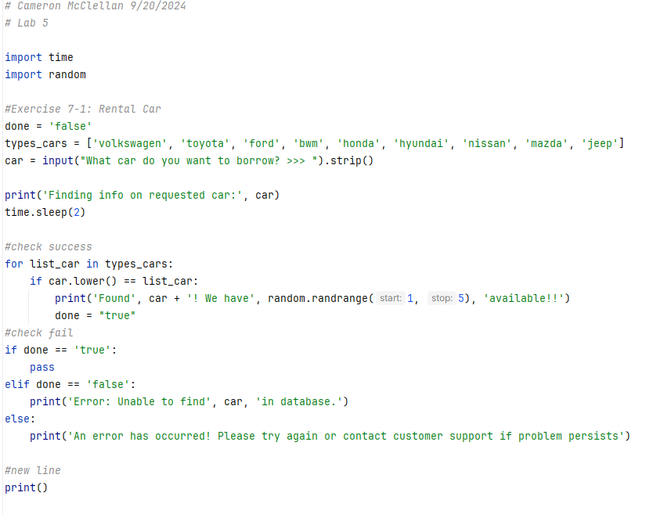

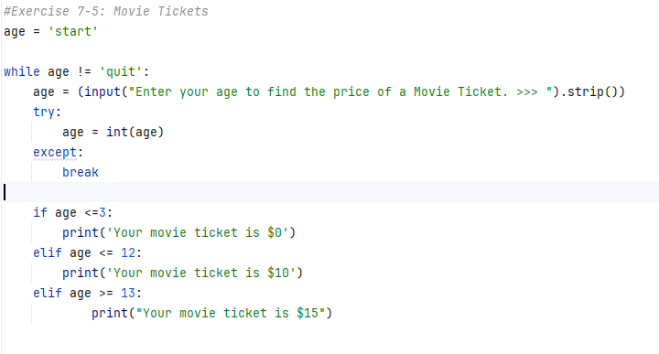

Output
